

Dr. James, Bradford inc.

2016-02-07

Dr. Bradford

69160 Hernandez Walks Suite 401, East Alexland, AK 10045

Phone: 3867454174

Fax: 9140845843

**Re:** Briana, Miller

**PHN:** 8721657376

**Birthdate:** 23-Aug-2001

**Address:** PSC 5779, Box 5760, APO AA 80472

**Patient number:** 3060620184

To Whom It May Concern:

This is a medical letter to state the above patient is pregnant with expected delivery date of 23-Aug-2025. Hoping this information is satisfactory for your requirements.

Thank you.

Sincerely,

Dr. James, Bradford

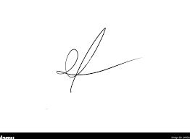

FRCS© NCMP

Clinical Assistant Professor, UBC

Department of Obstetrics and Gynecology SMH